Lab 7.2 – Implement the new buttons

The enhanced version of the Task Manager has 3 new buttons:

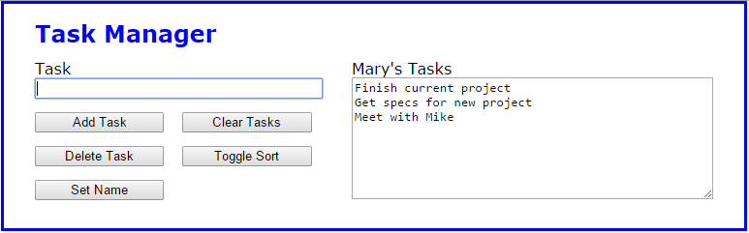

1. Open the files in this folder
2. Test the application in Chrome. Only the ‘Add Tasks’ and ‘Clear Tasks’ buttons are working.
3. Press the F12 key to review the local storage items.
4. Review the JavaScript file for the application. First, there’s another global variable named sortDirection with an initial value “ASC” (ascending). Second, there are 3 empty function expressions called deleteTask, toggleSort and setName. Last, the onload event handler attaches these functions as the event handlers for the click events of the 3 new buttons.

**Code the deleteTask event handler**

1. Code the deleteTask function so it uses the prompt method to ask the user for the index number of the task to delete. Assume the entry is valid, and use the splice method of the tasks array to delete the element at the specified index. Then, use the join method and the pipe separator (“|”) to create a string from the tasks array, update the localStorage value with the string, and call the displayTaskList function to re-display the tasks. Now, test the function.
2. Add data validation to this function so the user’s entry has to be a number, but don’t display a message if it isn’t. Then, test this change to make sure that nothing is done if you enter an index value that isn’t in the array or a value that isn’t a number.

**Code the toggleSort event handler**

1. Code the toggleSort function so it sets the value of the global sortDirection variable based on its current value. So, if the current value is “ASC”, change it to “DESC”, and vice versa. Then call the displayTaskList function to re-display the tasks in the page.
2. In the displayTaskList function, find the line of code that calls the tasks array’s sort method, and comment it out. Below this line, add an if statement that checks the value of the sortDirection variable. If the value is “ASC”, call the tasks array’s sort method. Otherwise, call the tasks array’s reverse method. Test the change.

**Code the setName event handler**

1. Code the setName function so it uses the prompt method to ask the user for a name. It should then store the name in session storage and call the displayTaskList function to re-display the tasks in the page.
2. In the displayTaskList function, add code that gets the name value from session storage or an empty string if there’s nothing in session storage. Then, set the value of the span element with “name” as its id to either the name from session storage or an empty string if there’s nothing in session storage. Add an apostrophe and s (‘s) after the name as shown above.